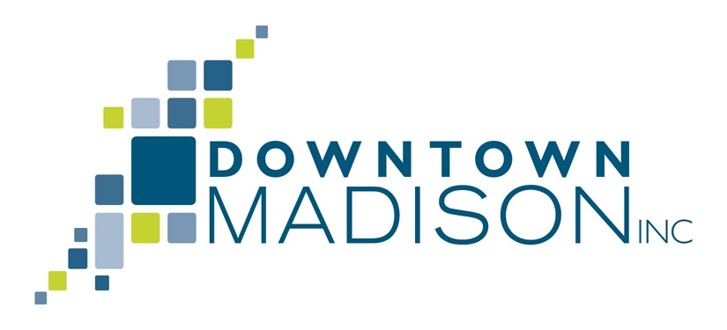

DMI Guest Registration Guidelines

While attending a DMI program is a benefit of DMI membership DMI members are welcome to invite guests to a DMI New Faces, New Places or a What’s up Downtown breakfast program. Here is the procedure to follow:
- Pre-registration is required, please send an email to or call the DMI office (cahewitt@downtownmadison.org or 608.512.1335) by 10:00am the day before the program with the name and contact information for the guest.
- The cost to attend a DMI program is $20.00 per guest which is payable at the registration table, cash or check (payable to Downtown Madison, Inc.) – we do not accept credit card payments.
- When you arrive at the program you will find the guests name tag at the registration table.
It is important to register yourself and your guest in order for DMI to give the program host an accurate attendance number. This policy pertains to the DMI New Faces, New Places and the What’s up Downtown breakfast program. It is subject to change and some exclusions may apply. If your guest is interested in gathering information about DMI membership have them contact Carol Ann Hewitt, contact information show above.

